Learning TOGETHER AT Home

A Handbook for Families
Macedon Ranges Montessori Preschool hopes you are safe and well. Here are some ideas of things to do at home if you are isolating and feel like learning together.

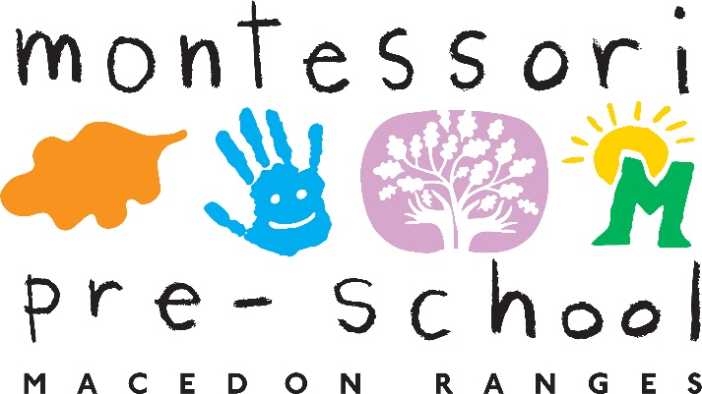

Learning from A Montessori Perspective

When embarking on a time of learning from home, our aim is to create a Montessori-based framework that serves our students while supporting families as we all adapt to a different daily routine. It is important to us that the children’s activity during this time be enjoyable, thoughtful, challenging, and rewarding.

Replicating what happens in our Kinder is not something we can achieve during this period. Our goal is to work in collaboration with families to keep alive the culture of learning that is unique to Montessori and provide families with support and activities that match the developmental needs and characteristics of each child in our community.

Montessori at Home
The Montessori method is all about the process. While completion of work is important, it is our approach that makes all the difference. Learning is most effective when it is within a greater context. When we connect subjects and concepts, we establish meaning which fuels motivation in students. Above all, we want children to feel connected to their learning, not simply “complete assignments” while at home.

Learning together with a sense of exploration, curiosity and discovery results in deeper and more meaningful experiences for children. This instils a great sense of ownership and responsibility for the child.

The Prepared Environment
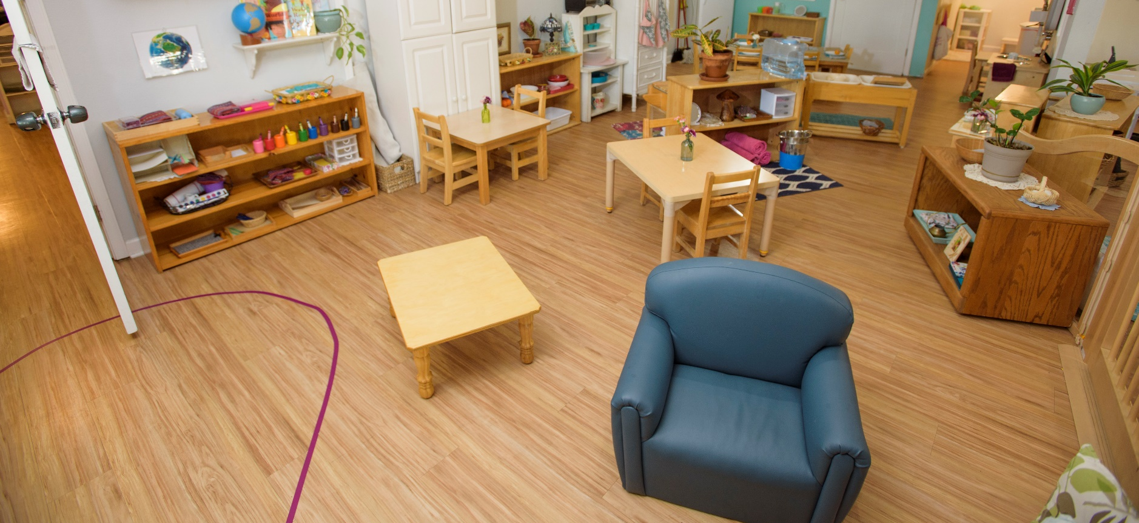

For our younger students, the learning environment is your home and surroundings. This means finding ways to support independence, engage in meaningful tasks and supplement learning through various activities suggested by teachers.

It is also important to establish a quiet space for when needed, expectations if you are working from home and routines that work for the whole family.
Where age-appropriate you might like to discuss learning from home with your child and include them in some decision-making processes:

• Ask them where to set up their space (if applicable)
• Make a schedule together that works for your family (when to take breaks / have time outdoors etc.)
• Gather ideas for activities and projects
• Organise materials

Overall, we can approach this as an opportunity to be creative and collaborative—we are here to support you through this process. Chat to us with any assistance we can guide you through.

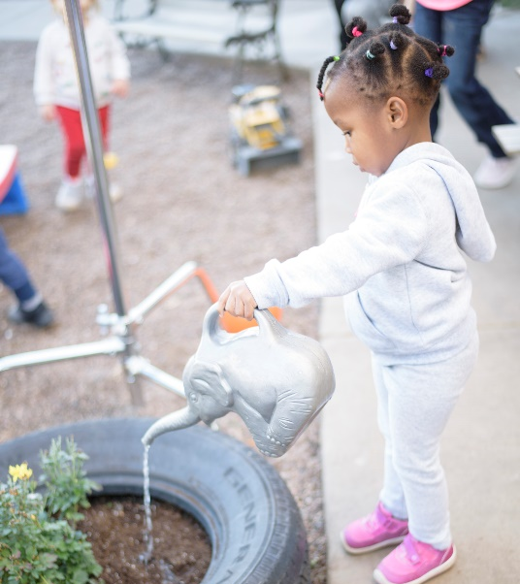
Practical Life
Practical life is an important part of learning. It is part of every Montessori school and this part of the learning environment is usually mirrored on what would be happening in your home. These activities assist children in developing purposeful life skills for their continued growth and development. The main goal is to build your child’s independence. Children gain a strong sense of wellbeing and esteem knowing they are a valued contributor in their family life. Children refine fine motor and movement skills and practice body coordination, planning and problem solving.
Practical Life learning experiences build:
- Concentration
- Independence
- Self esteem
- Self-regulation
- A sense of community

Inherent in these activities is the development of key executive functions: decision making, organization, problem-solving, impulse control, collaboration and communication. These skills form the foundation of a child’s academic learning. For example, sequencing a task from left to right is a pre-reading skill.
Examples of practical life might include:
• Setting The Table;
• Watering Plants;
• Tidying And Organising Rooms;
• Planning An Outing;
• Taking Care Of Pets;
• Preparing A Snack/Meal;
• Helping With Shopping Lists; Or
• Keeping A Small Garden.

Practical life is engaging for children at all stages of development and tasks are designed according to their level of coordination and independence. An older child might wash the car and younger child might hand you pegs for the line. You can organise a job chart or list of family projects as a way to help guide your child’s interests. Planning and gathering resources to complete the tasks is purposeful work. These ideas foster a sense of contribution, responsibility, shared experiences and satisfaction.

As our children get older, these activities lead naturally to volunteer experiences and beginnings of community work. For adolescents, being involved in practical life experiences are the foundation of their sense of belonging and personal vision.

The Work Cycle

Establishing a routine that works for your family is an essential first step to creating a successful learning environment at home. Children are very familiar with this framework from preschool. In a Montessori classroom, children are given blocks of time in order to explore their work deeply. This contributes directly to the development of concentration and provides opportunities to collaborate and problem-solve. It is the framework that fosters child- centered as opposed to teacher-directed learning.

Working Together at Home
Montessori learning environments are often referred to as “optimal learning environments” because of the inherent skills and outcomes that result from being in a rich and interesting classroom, coupled with the dynamic of interactions amongst peers and teachers.

In order to foster a deep sense of ownership in their learning, we focus on two things: the developmental needs and characteristics of the child and their interests. Here are a few key points that aid in cultivating a child’s self-direction and attention to their work:
• Choice
• Participation in planning and organizing tasks
• Conversation
• Finding good resources
• Sharing of knowledge

A note regarding sharing and presenting work:
It is a regular occurrence in a classroom for children to present their work or projects to one another. This can be replicated at home for your children. Your Kinder child and older children can plan a presentation or sharing time. This is very exciting for young children and gives our older students an opportunity to use their voice. It is an essential part of the learning process as it requires synthesis of learning to describe, explain and express yourself clearly. It feels celebratory as well!

Responsibility and Contribution to Community

Being in a Montessori school or “Children’s House” is often described by students as being part of a big family. All of the aspects detailed above result in a feeling of belonging to a community and with that, we learn that there is a responsibility to ourselves, others and the environment. It is our commitment to each child at Macedon Ranges Montessori Preschool that they reach their fullest potential and feel that they are a valued part of our community.

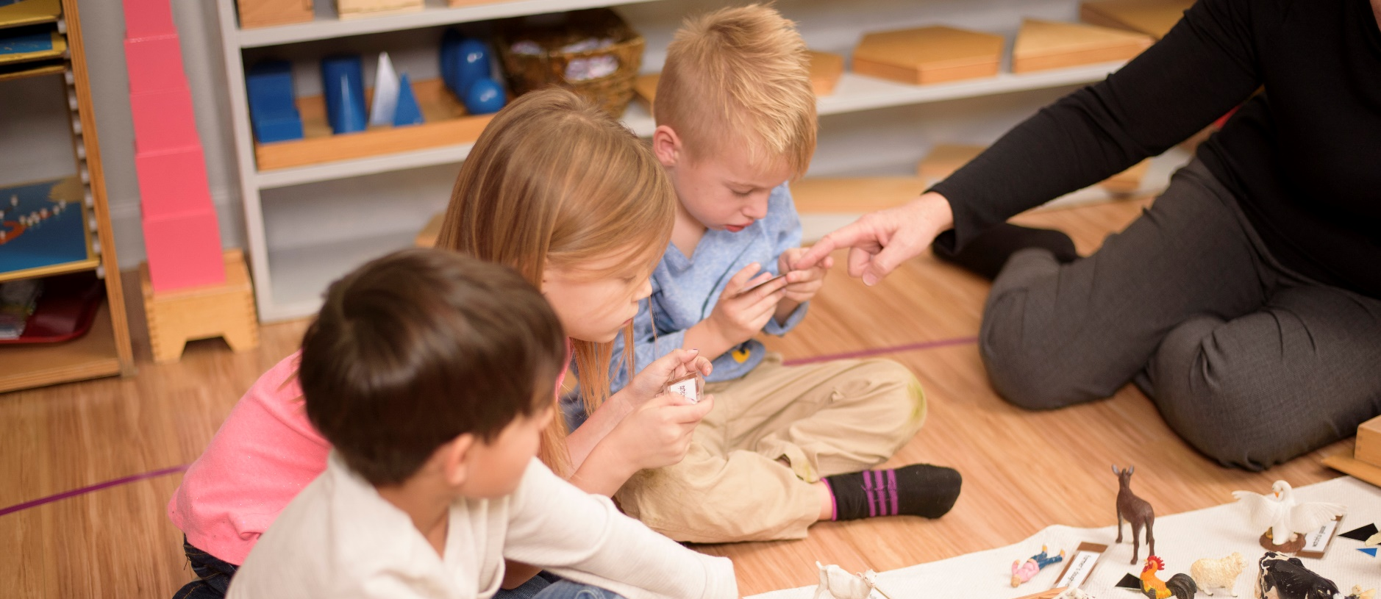

Kindergarten Children

SUGGESTED SCHEDULE

Early Morning | Set up and clean up breakfast, load the dishwasher.  Basic chores: collect dirty clothes, sort laundry, help load the washing machine.  Prepare morning snack (place in accessible area to be eaten  later), clean up.
Mid-Morning | Uninterrupted work cycle. Children should engage in activities to practice skills for practical life, sensorial work, language, culture or math.
Lunch | Prepare (set up, clean up) lunch.  Quiet Time: this may include a rest, reading books, handwork, reflective time. No screen time.
Afternoon | Afternoon work time include some outdoor learning experiences. Include time for preparation for the next day.

Preparations for the next day and chores can be performed throughout the day.
Activities can be modified according to child’s readiness and developmental needs.

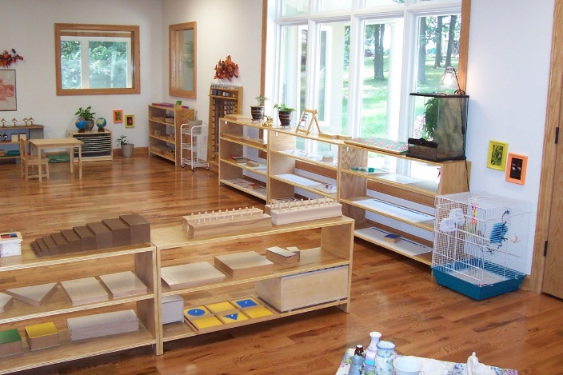

Suggested Learning Experiences

SET A FAMILY GOAL:

- Enjoy family life with developmentally appropriate contributions.
- Respect everyone’s role and health
- Allow everyone time to complete their work/ learning

FAMILIES ARE INVITED TO:

- Remain mindful about your child’s stress or worries during this time of change.
- Initiate communication with teachers about questions, ideas, concerns, or feedback.
- Support your child’s independence in daily life activities.
- Be mindful of and allow children to continue periods of concentration.
- Establish daily routines and expectations.
- Limit screen time.
- Provide opportunities for daily physical activity.

EARLY LEARNING STAFF

- Initiate individual communications based on student needs.
- Give guidance in setting up a daily routine.
- Make suggestions for appropriate house chores.
- Offer guidelines and suggestions for screen time.
- Provide both general and individual suggestions for activities developing fine motor skills, gross motor skills, language, and math.
- Be prompt in replying to your emails if you need additional guidance and support.

PROGRAM-SPECIFIC NEEDS AND CHARACTERISTICS

Children aged 3 to 6 thrive in environments that promote repetition, routine and the mastery of purposeful movement.
- Allow your child to choose activities and give the opportunity for periods of time without distractions.
- The key to a successful learning environment is order, access to tactile resources, space to explore and meaningful activity. For the Primary child, work and play should be interchangeable—a natural, fun and exciting part of life.

PRACTICAL LIFE

Ages 3 to 4:
- Meal or Snack Preparation: slicing vegetables, fruit, cheese, etc.
- Baking: measuring and mixing ingredients.
- Kitchen Care: loading and unloading the dishwasher, washing dishes by hand, sweeping floors.
- Pet Care: walking, playing with, and grooming.
- Dusting: the leaves of plants with a house.
- Nature walks in the yard or about the neighborhood with a list of things to find.
- Walking on the Line: make a masking tape line throughout the house and walk carefully on the line.
- Art: coloring, painting, collage, sidewalk chalk.
- Cutting and gluing - for example find and cut all of the plants in a magazine; glue into a collage.
- Sewing shapes/pictures onto napkins, hand/kitchen towels, etc.

Ages 5 to 6:
- Cutting out (advanced pictures -mammals, birds, amphibians, etc.)
- Baking: reading, measuring and mixing simple recipes.
- Handwork: crocheting, finger knitting, or sewing words, initials, or pictures on napkins, hand towels, etc.
- Origami

SENSORIAL

Ages 3 to 4:
- Exploring the home for 2 dimensional shapes (rectangles, squares, circles, etc.).
- Exploring the home for 3 dimensional shapes (spheres, cylinders, cones, cubes, prisms).
- Explore the home for textures that are rough or smooth.
- Exploring sound by tapping on different objects (pot, glass….)
- Match items by what they are made of
- Find the coldest, hottest, tallest, smallest….object or place in the house.

Ages 5 to 6:
- Exploring spices and attempting to recognize them by scent.
- Comparing the various shapes of leaves found amongst the house plants.
- Drawing a picture that includes certain shapes i.e., 1 circle and 3 rectangles, or 1 square and 4 triangles).

LANGUAGE

Ages 3 to 4:
- Sound Games/I-spy: Something that begins with the sound /s/, ends in the sound /r/, or has a /m/ in it.
- Question Game: Have a conversation using who/what/when/where/why questions.
- Learn new songs and poems
- Tracing shapes in different ways.
- Draw and talk about a family event.
- Match letters, find letters, write letters.

Ages 5 to 6:
- Write a letter to a friend or family member to mail.
- Assist in writing list of things to do for a day or a week.
- Write a story or a play and read aloud or act out when finished.
- Label things around the house
- Act out verbs together
- Talk about nouns, verbs, adjectives e.g. describe the dog. What is it doing? The smelly, brown, shaggy, fast dog is panting.
Read books together every day as a family

MATHEMATICS

Ages 3 to 4:
- Scavenger hunt/counting objects collected.
- Counting objects (beans, pennies, etc.).
- Sorting laundry.
- Sorting silverware.
- Counting objects
- Looking for numbers in books
- Home map and clues – left and right

Ages 5 to 6:
- Hopscotch math—all operations can be done, just make your hopscotch go higher than 10.
- Math facts with dice.
- Matching cards
- Addition, Subtraction of objects
- Measuring objects around the house
- Looking at money
- Surveying the family on topics
- Plan a schedule with times – learning time on the clock

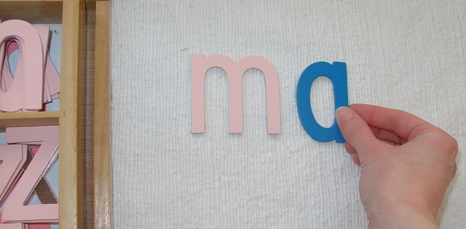

CULTURE

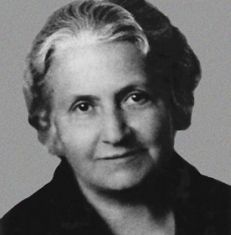
Ages 3 to 4:
- Observe and record animals outside
- Look up different places on maps
- Read about different places
- Sort Animals – pictures or figurines
- Label things you know
- Grow some vegetables from scraps
- Do a science experiment
- Find out about an artist
- Build the tallest tower
- Make an obstacle course

Ages 5 to 6:
- Draw maps
- Draw flags
- Do a mini project on an animal or plant
- Cook something
"One test of the correctness of educational procedure is the happiness of the child." - Maria Montessori
- Help someone
- Make a memory game about a topic of interest
- Look at books on a topic
- Look up the NASA kids website and explore the solar system
- Learn about what people do in other countries
- Learn words from other languages
- Learn about the first Australians in your area
- Learn about a famous person – Maria Montessori, David Attenborough
- Invent something

Many Thanks to the Montessori School of Tokyo for their support in the creation of this document.

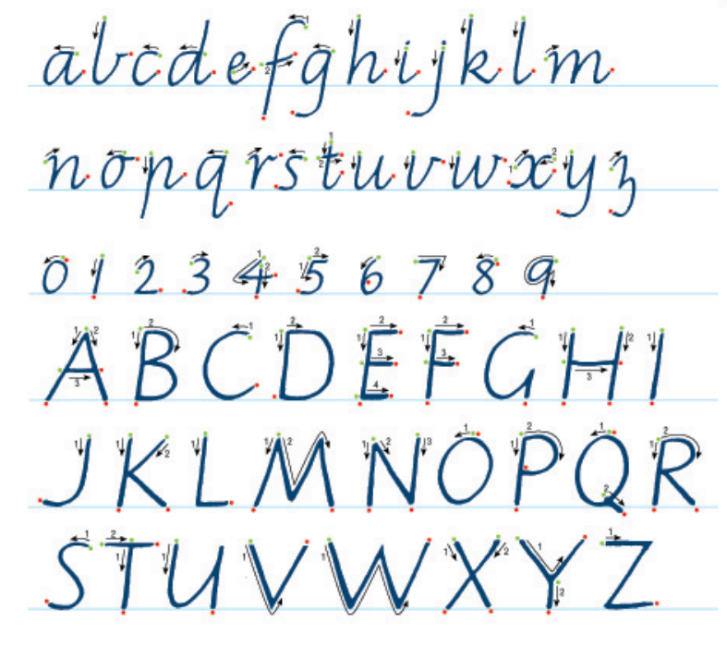
When teaching your child to write use the font they will learn ast school:

The quick brown fox 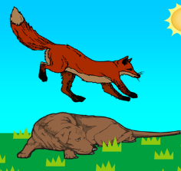jumps over the lazy dog.

When talking about letters use letter sounds in preference to letter names.
Sight Words
(Can not be sounded out – make flashcards or play memory with these words)
the
said
day
me
he
she
we
be
I
you
what
why
who
school
people
do
all
like
one
to
by
have
want
please
happy
Words to Sound Out
at
ant
mat
and
tap
lamp
hen
get
leg
net
pen
jet
sent
in
rip
win
milk
on
lot
pop
dot
mop
stop
nut
cup
tub
pump
Letter | Sound | Name  (Like the alphabet)
a | a – (aa) apple | a – (ay)
b | b – (buh) bin | b – (bee)
c | c – (cuh)cup | c – (see)
d | d – (duh) dog | d – (dee)
e | e- (eh)egg | e- (ee)
f | f – (ff) fan | f – (eff)
g | g – (guh) gum | g – (jee)
h | h- (huh) hat | h – (haych)
i | i – (ii) in | i – (eye)
j | j – (juh) jam | j – (jay)
k | k – (kuh) kit | k- (kay)
l | l – (lll) lap | l – (ell)
m | m – (mm) mao | m – (em)
n | n – (nnn) nap | n- (en)
o | o – (o) on | o – (oh)
p | p – (puh) pin | p – (pea)
q | q – (qwu) quit | q- (cue)
r | r- (rrr) rib | r – (arr)
s | s – (ss) sand | s – (ess)
t | t – (tuh) tap | t – (tee)
u | u – (uh) up | u – (you)
v | v - (vv) van | v – (vee)
w | w – (wuh) win | w – (double you)
x | x – (ks) fox | x – (ex)
y | y – (yuh) yes | y – (why)
z | z – (zzz) zip | z – (zee)

Resources
Montessori Early Learning - https://www.alldayprimary.com/
Montessori Classified Cards - https://montessoridigital.org/node/7514
Counting Beads - http://montessoritools.org/bead-bars/
Moveable Alphabet - http://montessoritools.org/moveable-alphabet/
VIC Education Early Learning - https://fuse.education.vic.gov.au/EarlyChildhood
NSW Early Learning Packs - https://sites.google.com/education.nsw.gov.au/ec-guided-learning/
Explore – Museums, Aquariums, Zoos, Countries, Cities virtually for example - The Smithsonian National Museum of Natural History https://naturalhistory2.si.edu/vt3/NMNH/2
Bush Kinder Ideas - https://www.natureplay.org.au/coronavirus-covid19-resources
ABC Kids Early Learning Ideas - https://www.abc.net.au/abckids/early-education/curriculum-areas/11980110
TWINKL Early Learning Home Packs - https://www.twinkl.com.au/resource/eylf-school-closure-home-learning-resource-pack-au-t-10002028
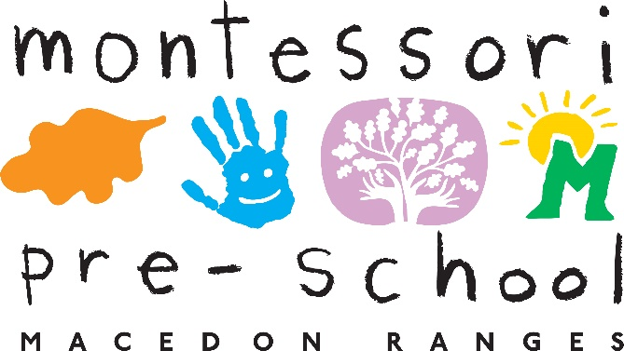

61 Main Road, Riddells Creek Victoria 3431
03 5428 6376
www.macedonrangesmontessori.com.au

